Project Plan

# Description:

The project I have decided to work on is a COVID-19 information website. COVID-19 also famously known as coronavirus is a contagious disease caused by severe acute respiratory syndrome coronavirus 2 (SARS-CoV-2). It originated from China, Wuhan in December 2019. The disease has spread world-wide and is still an ongoing pandemic. It has been almost a year and a half, and the pandemic still has not quite down yet. The main reason is because of the negligence of the common folk. Even after a year and a half, some still do not take precautions and do not consider COVID-19 a threat. People are not aware of the seriousness of this pandemic.

Therefore, I have decided to make a COVID-19 information website that will provide information to the user about the coronavirus and make people more informed.

# Evaluation:

Following are the 4 related websites that I have evaluated:

* **WHO (World Health Organization):** First one has to be WHO, which is a specialized agency of the United Nations responsible for international public health.
* **CDC (Centers for Disease Control and Prevention:** CDC is also one of the national public health agency of the United States.
* **NIH (National Institute of Health):** Like the previous ones NIH is also responsible for biomedical and public health research and is an agency of United States.
* **HHS (United States Department of Health and Human Services):** The HHS, also known as the Health Department, is a cabinet-level executive branch department of the U.S. federal government with the goal of protecting the health of all Americans and providing essential human services.

# Purpose:

The main purpose of the website is to provide information. Transmission of COVID-19 happens basically when a contaminated individual is in close contact with someone else. Little drops containing the infection can spread from a tainted individual's nose and mouth as they inhale, hack, wheeze, sing, or talk. Others are contaminated if the infection gets into their mouth, nose or eyes. Airborne transmission is likewise in some cases conceivable, as more modest tainted beads and particles can wait noticeable all around for quite a long time to hours inside encased spaces that have insufficient ventilation. Less ordinarily, the infection may spread by means of polluted surfaces. This is what makes COVID-19 a serious threat.

Thus, this website will have the purpose of providing information to its users will be the fastest way to see how to handle the crisis.

# Target Audience:

This project will not have a specific target audience. Anyone can be a user since this is an information website about COVID-19.

# Site Map:

# 

# Wireframe Diagram:

**Home Page:**

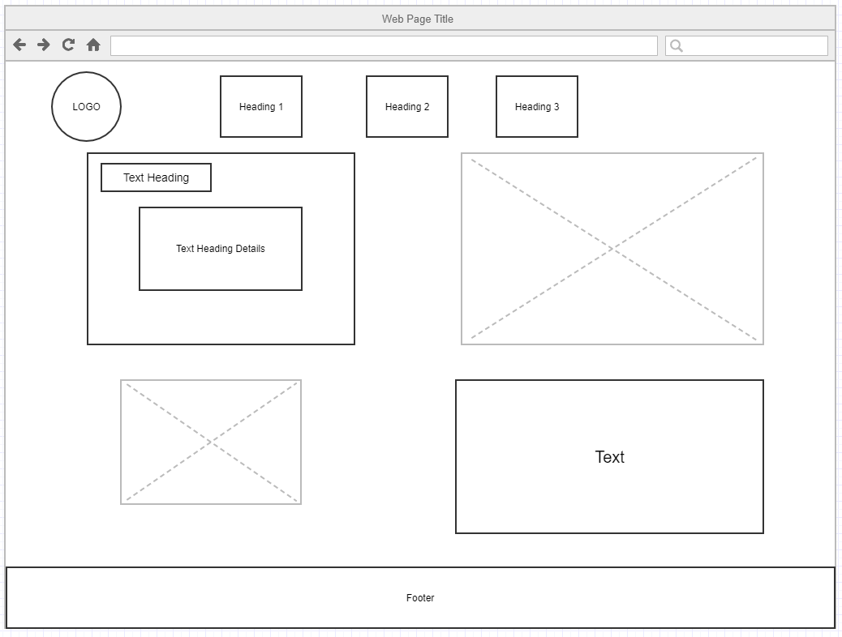

**Symptom Page:**

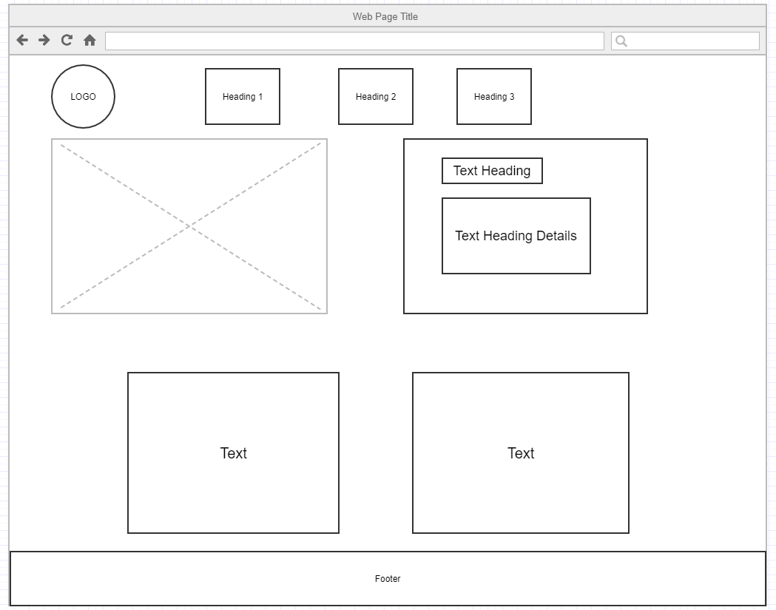

**Information Page**



**Treatment Page:**

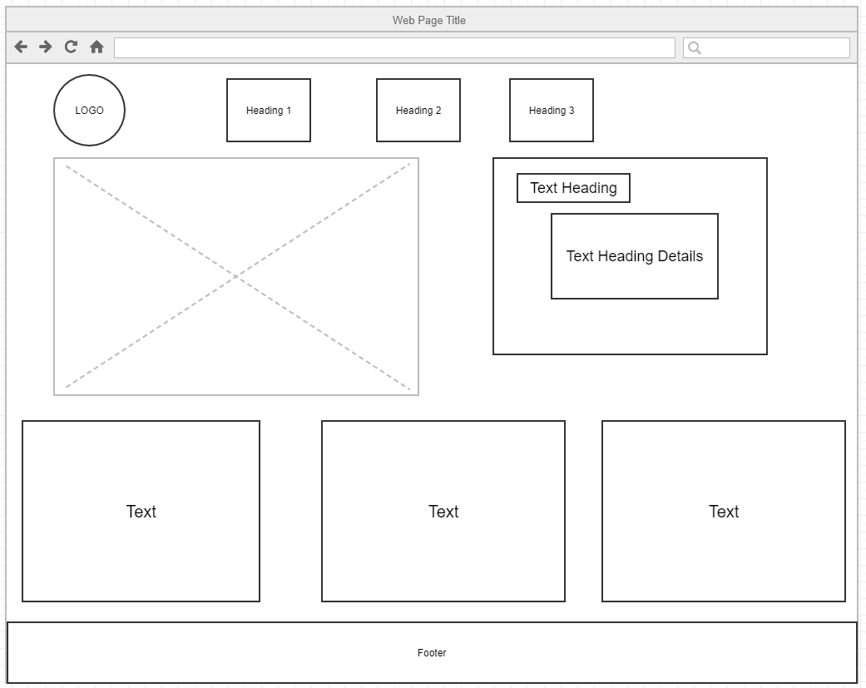

**Form Page:**

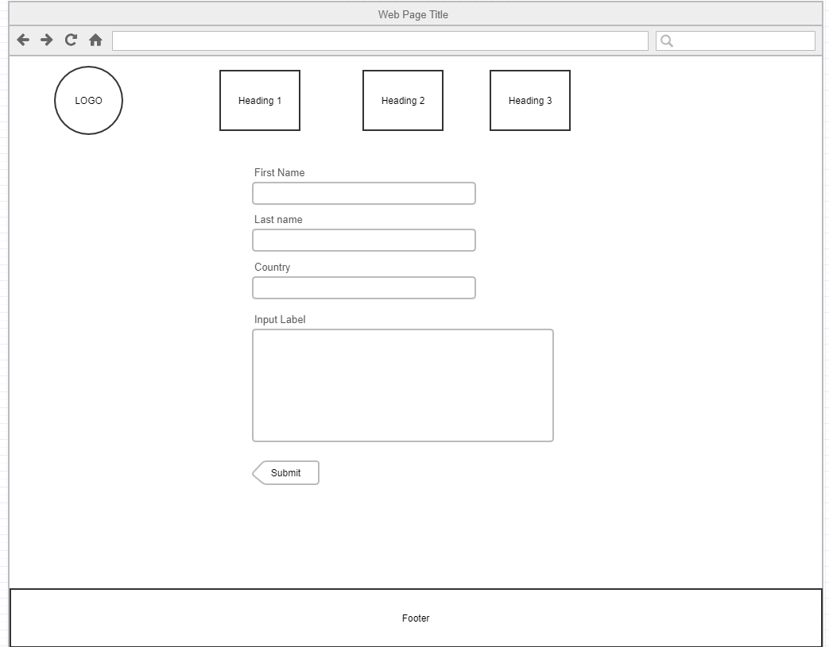

# Storyboard:

**Screenshot of home page design**

**Part 1**

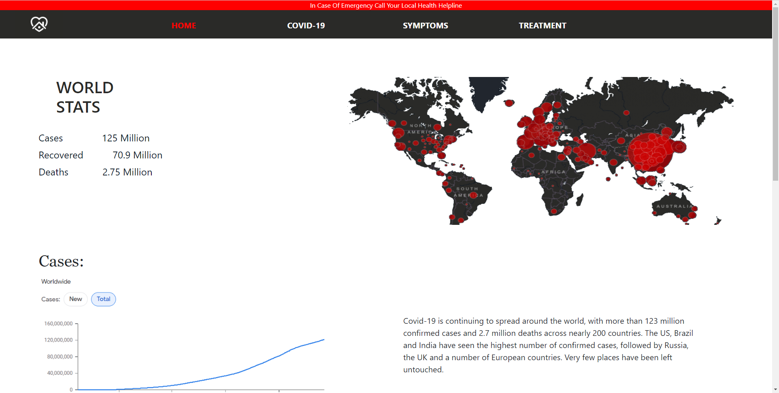

**Part 2**

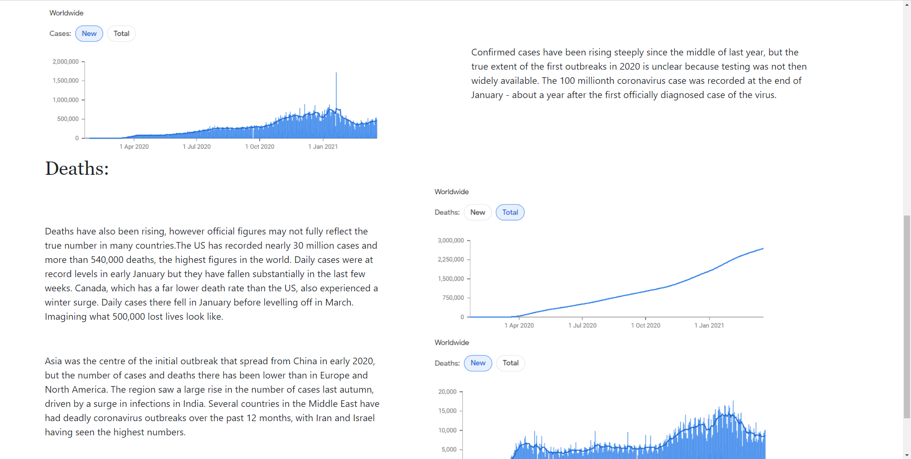

**Part 3**

